**Design Document - Online Chat Application**

1. **Purpose:**

An online text chatting application which allows users to exchange messages with each other. It can be made as an application which could be ported to android, ios, or other current mobile operating systems as well as be available on desktop platforms which we retain all the user’s conversations between platforms, while still scaling well with large groups of users.

1. **Architecture:**

The online chat application will use the format as that of a layered architecture. The high level design of the system is as follows:

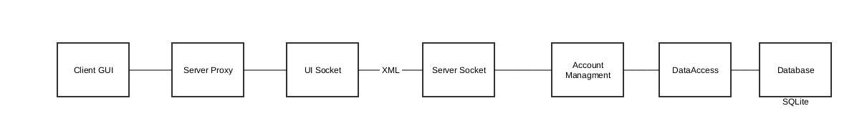

The data transfer between the client and server is done through xml using the XMPP protocol. The C# client system will be using the SS2.Xmpp library to connect to the server.

1. **UML Class Diagrams**

**Client side Class Diagram:**

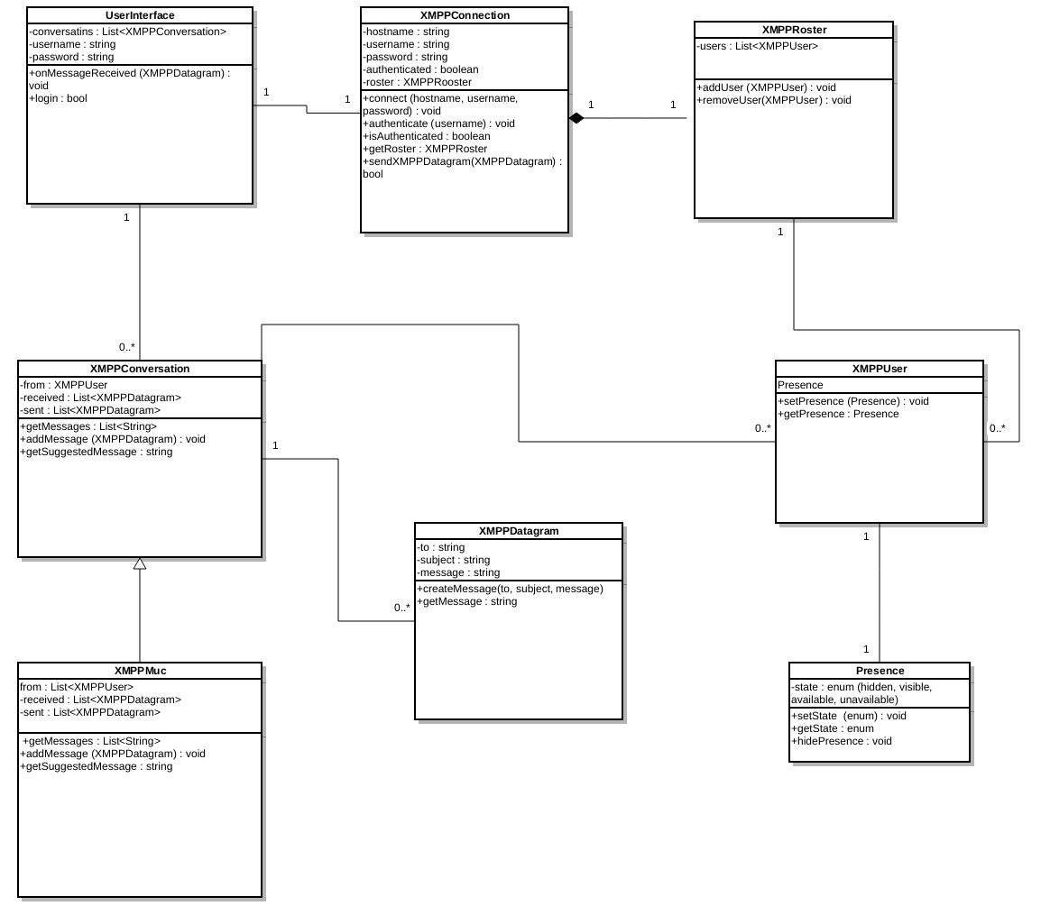

**Server Side Class Diagram:** 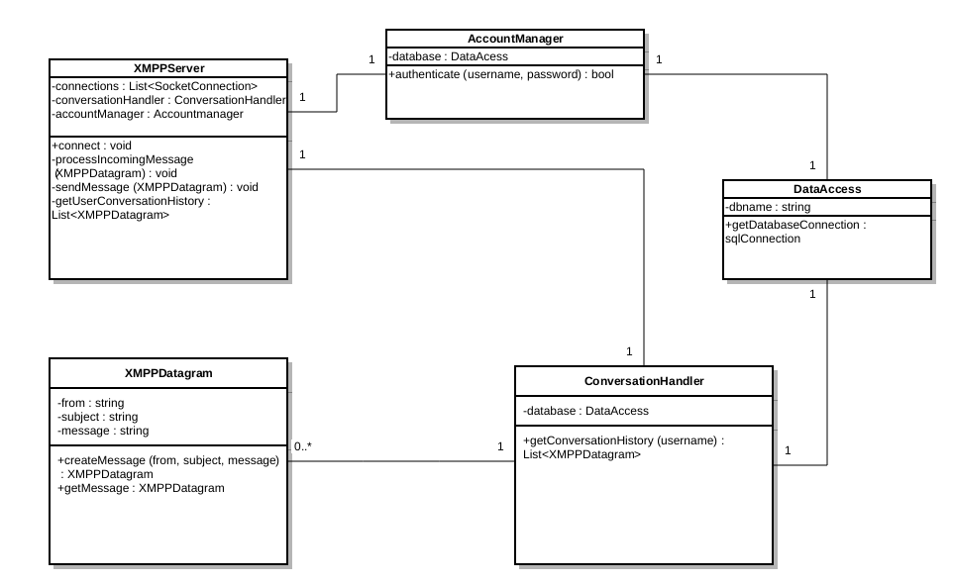

1. **Interaction (Sequence Diagrams and Use Cases)**

Sequence diagram for successfully connecting to the chat server and returning the user’s contact list will be as follows.

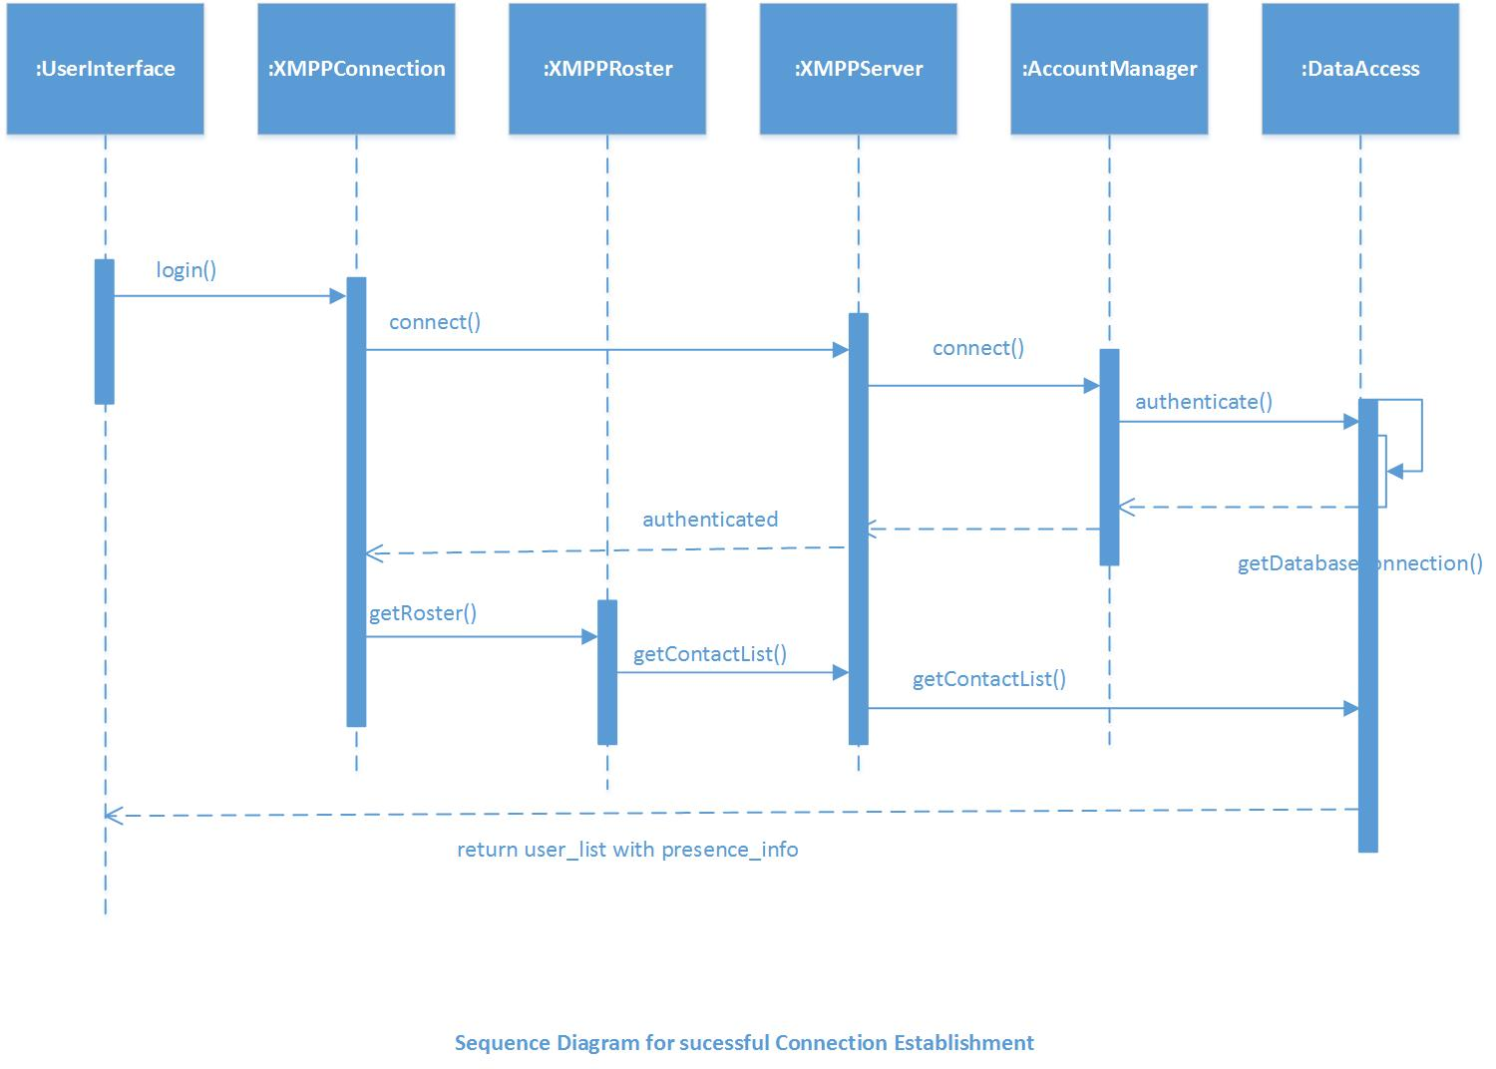

Use-cases for common scenarios:

